Requirements for “Tenants”

In ZVM:

1. ZVM must have “Enable Zerto SaaS Features” enabled under the “About” section of Zerto site settings

http://s3.amazonaws.com/zertodownload_docs/Latest/Zerto%20Virtual%20Replication%20Zerto%20Virtual%20Manager%20%28ZVM%29%20-%20vSphere%20Online%20Help/AdministratorforZertoVirtualManager/images/About_Cloud.png

1. ZVM must have port 443 open to <https://zerto-mobile-data.zerto.com>
2. ZVM version 5.5u4 or higher
3. User must be registered user in MyZerto with their work email domain address

How to Access “Tenants”

1. Log into MyZerto (www.zerto.com/myzerto)
2. Select “Cloud Control” from the navigation bar – will open in a new tab



1. Select “Tenants”



How to “Add” a new “ZORG” in “Tenants”

1. Click “Add” in the top right

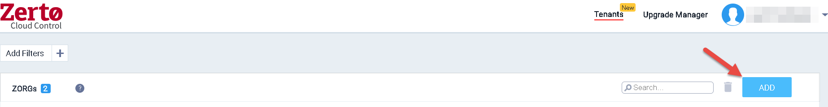

1. Select the appropriate ZORG by clicking on the “ZORG Name” field – note that typing in this field will filter the list.

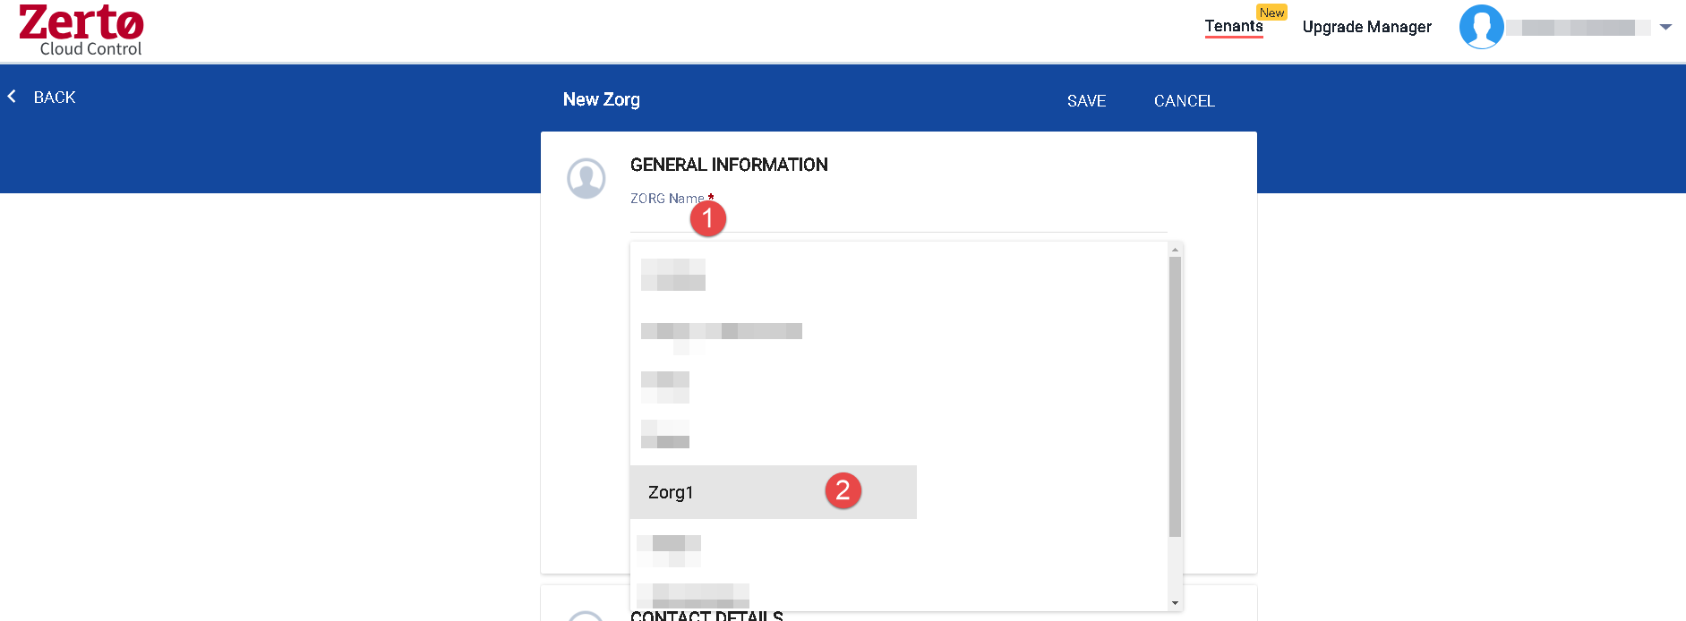

1. Fill in the other required fields.

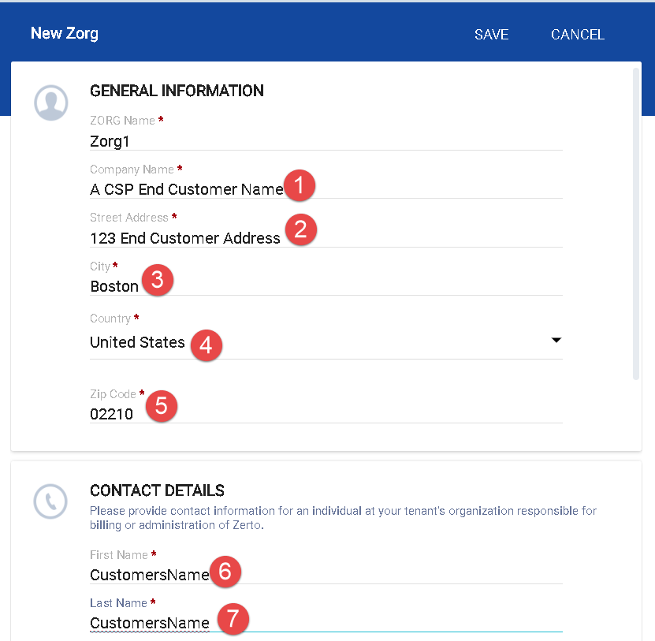

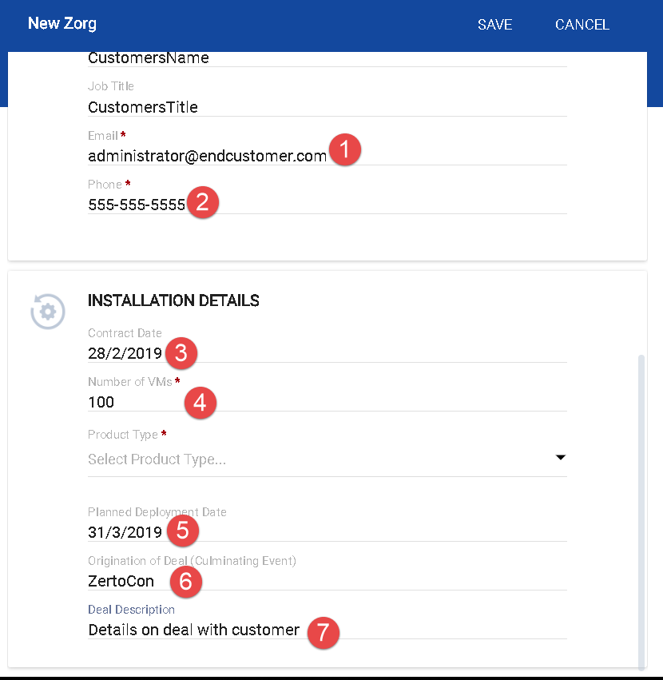

1. Select a product type
   1. Software Subscription: Zerto Virtual Replication (ZVR) provides protection for virtual machines in Service Provider site.
      1. **Usage for this ZORG is billed at the provider’s regular rate. (list $30)**
   2. Multi Cloud: ZVR Multi-Cloud (MC) enables one-to-many, simultaneous protection and recovery of VMs within on-premise and multiple Service Provider sites, for up to 3 sites
      1. **Usage for this ZORG is billed at the provider’s premium rate. (list $39)**
   3. Enterprise Cloud Customer: Enterprise Cloud Customers (ECC) with an existing perpetual ECE license and a valid maintenance and support agreement for such a license with Zerto, who will now be using a Service Provider for replication for one of their sites
      1. **Usage up to the enterprise customer’s ECE license amount for this ZORG is billed at $0.**

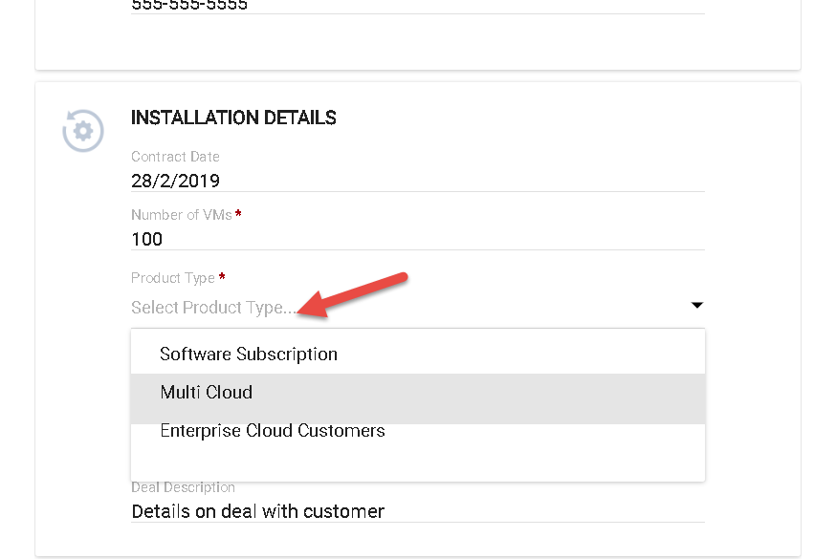

1. Click “Save”

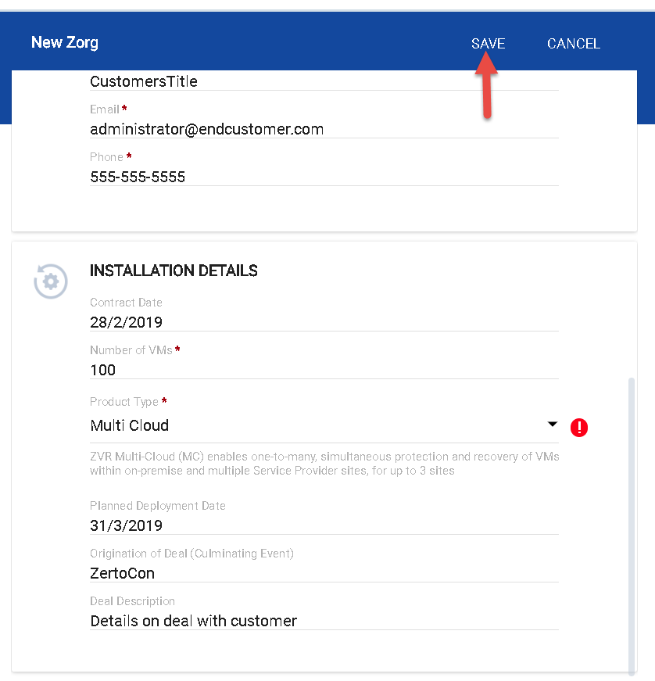

How to edit an existing “ZORG” in “Tenants”

1. Click the link for the “ZORG” you wish to edit

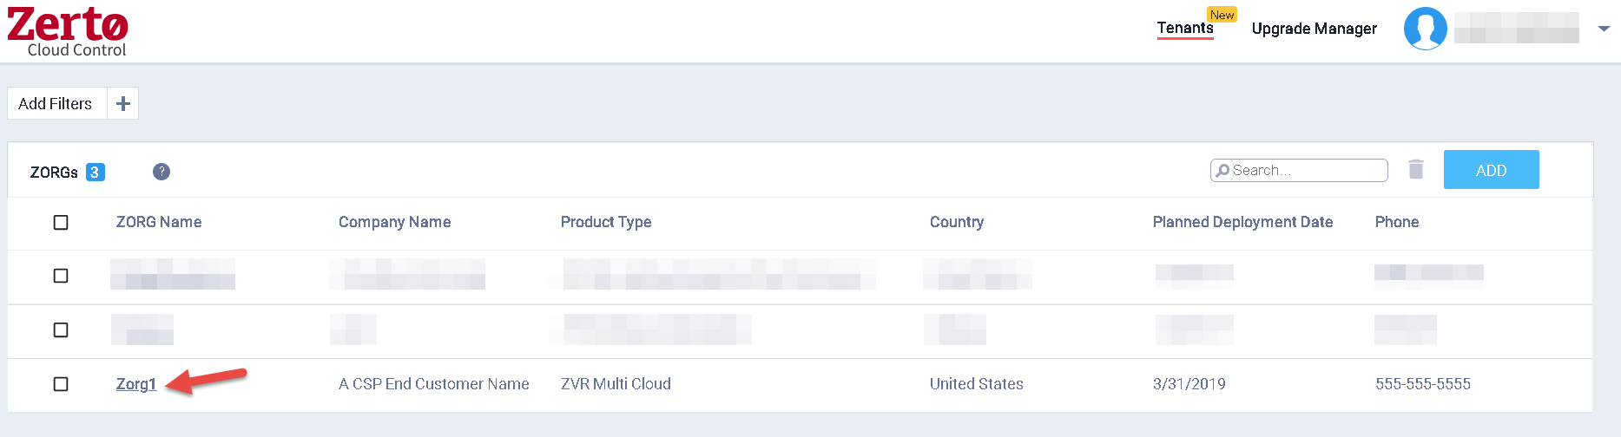

1. Click the “Edit” pencil icon in the top right

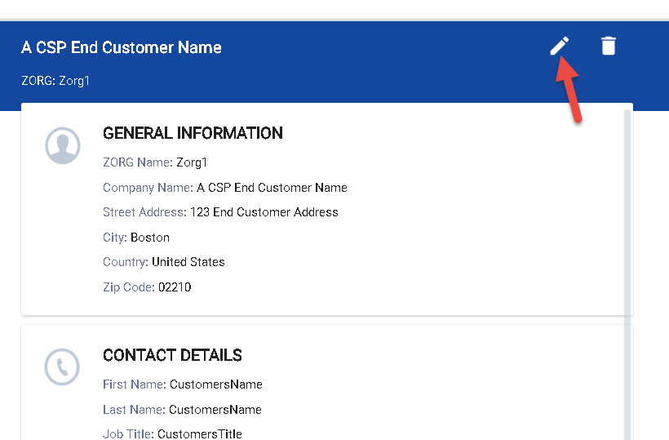

1. Make the desired changes and click “Save”

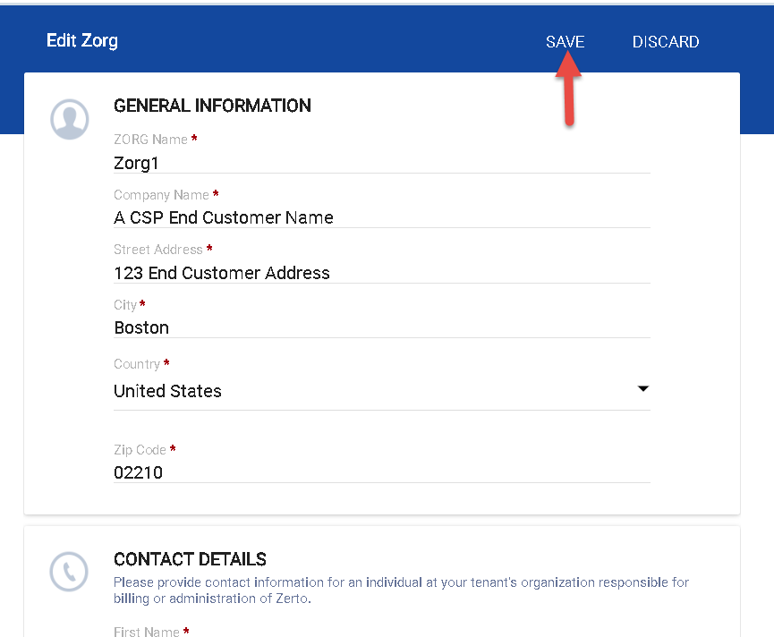

How to Delete a “ZORG” in “Tenants”

Method 1

1. Select the check box for the desired ZORG and click the “Delete” trash can icon

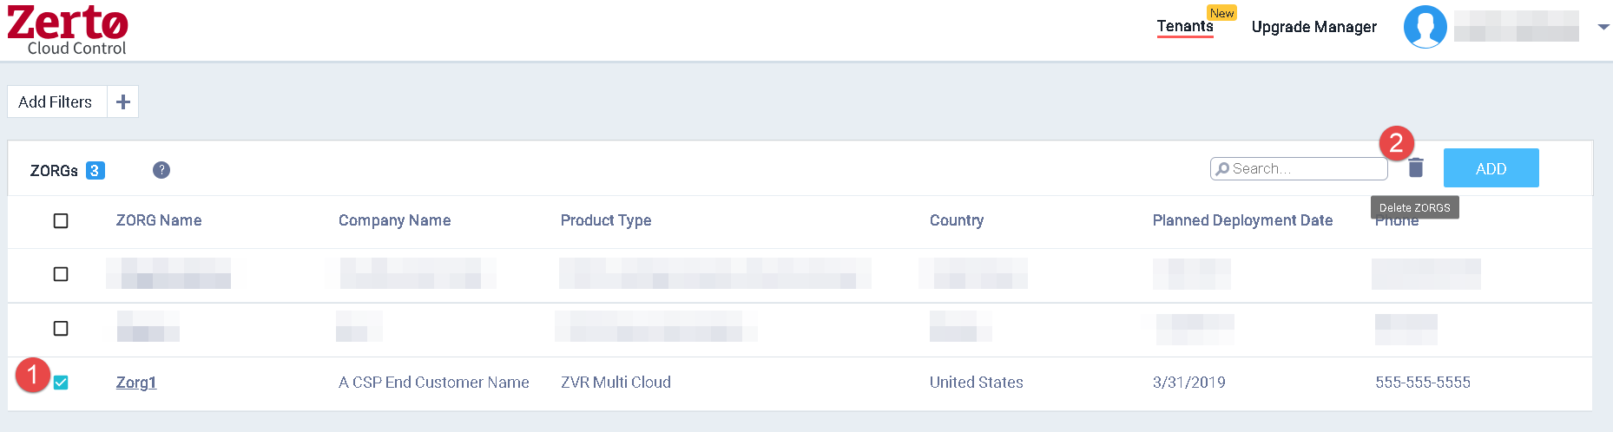

Method 2

1. Click the link for the “ZORG” you wish to delete
2. Click the “Delete” trash can icon in the top right

